|  |  |  |
| --- | --- | --- |
| **Year 12 Essentials**  **Test 2** Perimeter, Area, Surface Area and Volume **Name:________________** | | |
| Resources allowedCalculator1 A4 page of notes | Total Time: 50 minutes | Marks: _______ / 52 Weighting: 5% |

Q1) Find the Perimeter of the following shapes (4 marks)

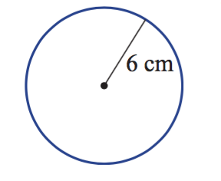**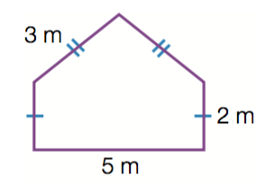 a b**

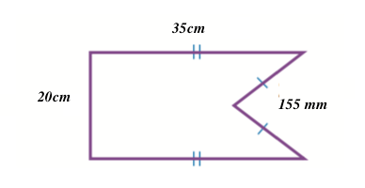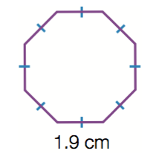 **c d**

Q2) A security guard walks the perimeter of a rectangular building. He walks 400m in total. If one side of the building is 75m, how long is the longer side? (2 marks)

Q3) Find the area of the following shapes (4 marks)

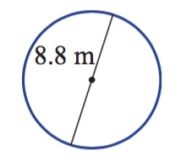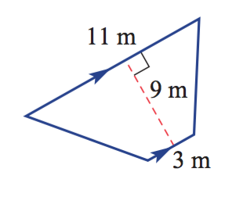 **a b**

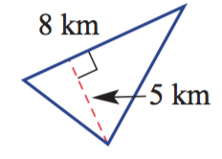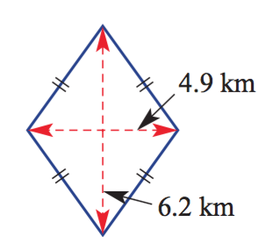

**c d**

Q4) Find the area of these sectors and composite shapes (12 marks)

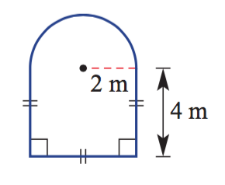 **a**

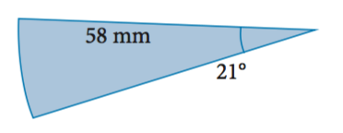**b**

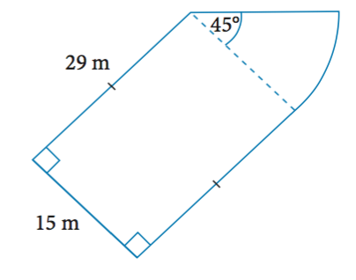

**c**

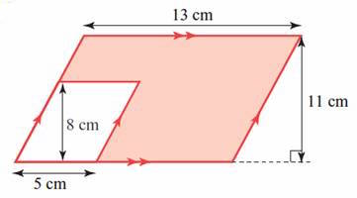**d -** Find the shaded area of the shape below

Q5) A farmer wants to section off his paddock to enclose his sheep. The paddock is 400m wide, with a fence lining the left hand side that is 1000m long. The right hand fence is 750m long. The back of the paddock enclosure is a diagonal line 472m long, joining the left and right fence. The front of the field is a semi circle 400m in diameter. **What is the total area of the field?** (3 mark)

1. Draw a Diagram of the scenario.
2. Find the total area of the paddock.

Q6) Find the surface area of the following shapes (13 marks)

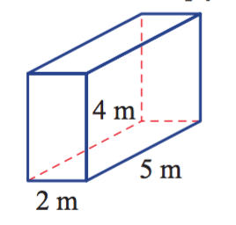 **a**

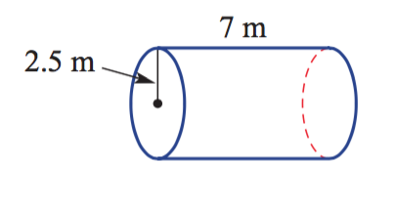**b**

**c**

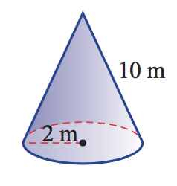

**d**

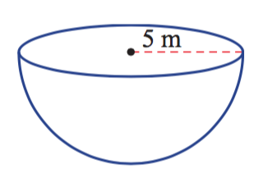

**e** *hint – use Pythagoras to find “l” first.*

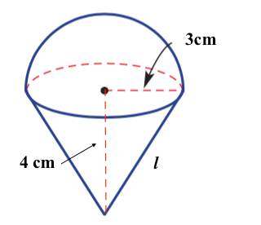

Q7) The local aquatics center wants to know the surface area of their pool so they can repaint the interior.

1. 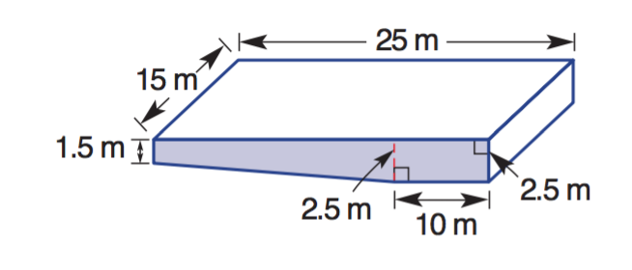Calculate the surface area of the pool below. (14 marks)

1. If it costs $15 per square meter to paint the pool base. How much would it cost to paint the pool currently?
2. They decide to extend their swimming pool to become a 50m Olympic size pool. Olympic pools have similar width and depth specifications, but are 50m long, and have a deep end base length of 20m. Find the difference between the pool above, and the new pool to be built.
3. How much more paint would they need for the new pool?

END OF ASSESSMENT